Chaps Jewelry at Kohl’s

The Chaps brand name (by Ralph Lauren) spans many retail categories for ladies, men, and children. Product lines include: Apparel, Accessories, Hosiery, Luggage, Bedding, Bath and Dining. Kohl’s carries all Chaps product lines including jewelry which is what we will be servicing.

Fixturing:
- Chaps should be displayed on a combination of floor spinners and slat walls
- Not all stores will have the same fixturing.
- Some stores will use floor spinners or slat walls only
- Some stores have a 2 sided fixture displayed cross merchandised with the Chaps apparel – If your store carries “Cross Shop” it will be called out in your instructions
- Kohl’s has remodeled many stores and many different types of fixtures are now in use
- The most important thing is to keep Collections together when displaying
- Work with whatever fixturing the store has and display collections using Guidelines given below.
2 floor spinners 2 sided slat wall Cross Fixture V Tower w/ Slat
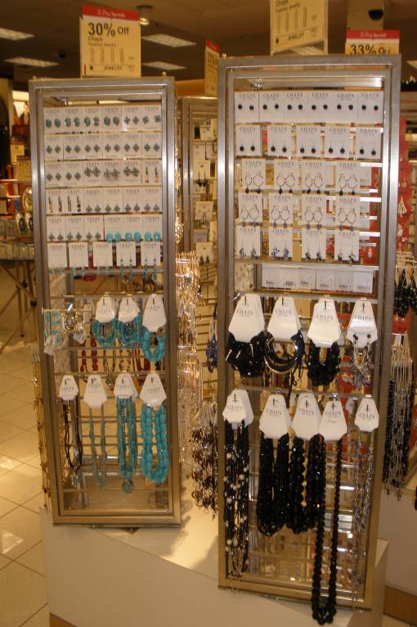
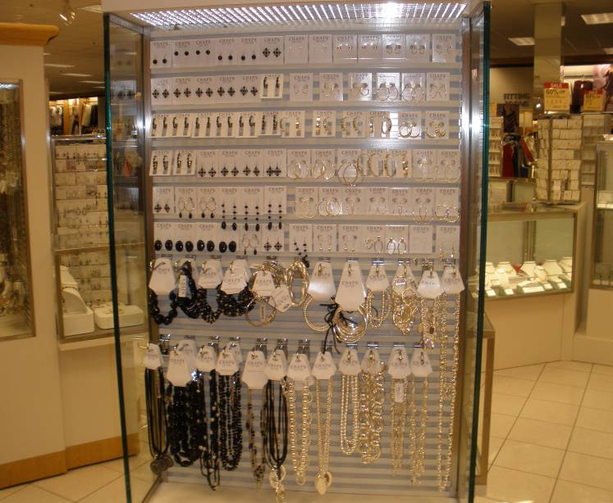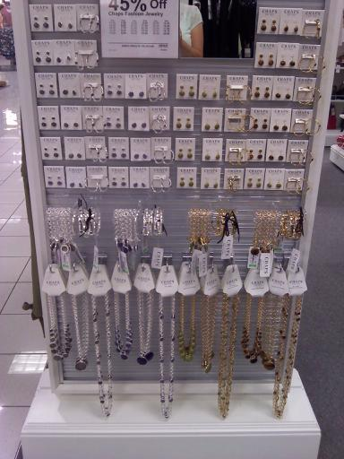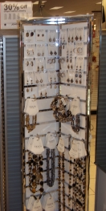
Slat Walls 4 sided Fixture
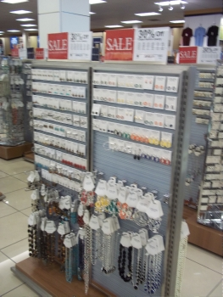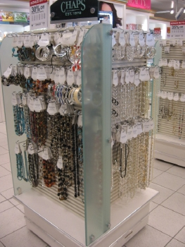
Product Boxes:
- Boxes are plain and state shipping from coast to coast on the shipping label
- Boxes may be kept behind the jewelry counter, under the spinner fixture, in lock up (receiving/stock room)
- Work with the Jewelry Manager to locate all new product shipments/backstock
Merchandising Guidelines:
- A Collection is a group of like type/style jewelry (earrings, bracelets, necklaces)
- Collections should always be displayed together following below guidelines
- Earrings at the top
  - Smallest styles (Buttons) at the top followed by hoops, dangles
  - Same style earrings should be displayed together
  - Keep the same number of earrings on each row
  - When using floor spinners that come to a V in the middle it is OK to display all earrings on one side with bracelets/necks on the 2nd side
- Bracelets are displayed below earrings on pegs or bracelet bars
- Fold over tags should be on pegs
- Bracelets without fold over tags should be on bracelet bars
- Minimum 3 pegs per row
- Maximum 5 pegs per row
- Pegs should not be staggered, they must stay on the same row
- You may display more than one bracelet/neck style per peg if necessary to get all styles displayed
- The clasp on the Pearl Bracelets and Necklaces should be showing
- Clasp has a script “C” on it that shows it is Chaps
- Gently tug clasp thru the fold over tag until it shows
- Necklaces should be displayed under the bracelets
- Display the same style Necklace under the same style bracelet
- Minimum 3 per row
- Maximum 5 per row
- All 36” or shorter necklaces should be displayed full length
- 60” endless pearl rope should be displayed double or triple looped
- Combining two different collections
- This is often necessary when collections have sold down and there is not enough left to fill a side of a floor spinner or slat wall
- Start with the lightest color (ex silver then gold – turq then red)
- Display all earrings of one collection
- then start over and display all earrings of the second collection
- Display bracelets and necklaces in the same manner as earrings
- Same color necks should be under same color bracelets
- Do NOT’s
- Do not display earrings below or between bracelets or necklaces
- Do not stagger pegs - they should all start on the same row
- Do not place bracelet pegs at the top or end of earring rows
- Do not leave empty pegs
Markdowns:
- The store is responsible for taking price markdowns
- A recent markdowns list will be provided to you for Audit/Correct
- Pull any jewelry not marked down and hand to the Mgr. for correction
- If markdowns are completed during your visit display on the sales floor
- Chaps Markdowns should be displayed on a markdown or clearance fixture with other marked down jewelry
- Goal is to get all marked down product out.
- Display as quickly as possible -do not need to follow guidelines
What to Display On Each Fixture
- Slat Walls Should Display Color Collections.
  - Collections should run top to bottom in columns of color
  - Start with Turquoise, then Coral, Blue and Black.
  - If you do not have enough of each collection to create columns of color you may display on the floor tower (1 color per side) and use the slat wall for the pearl, silver and gold tone jewelry.
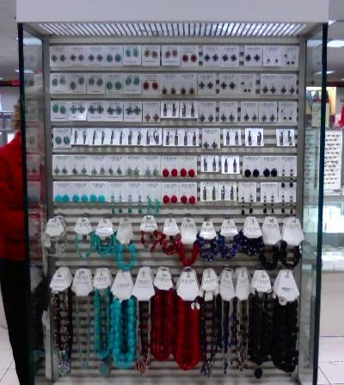

- floor spinners should contain “core collections” and featured collection
- Core collections are Silver, Gold Tone, Pearl
- The featured collection will be called out in your in store instructions
- You may have to alter what is displayed on each fixture according to fixturing given and the product in the store.
- If a Manager requests you change the display for any reason, you should honor their request.
- Report the request under comments.
Core Collections Silver and Gold Tone Mixed Collections


