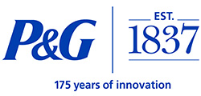
P&G Training Certification

- Background of Procter & Gamble (P&G)

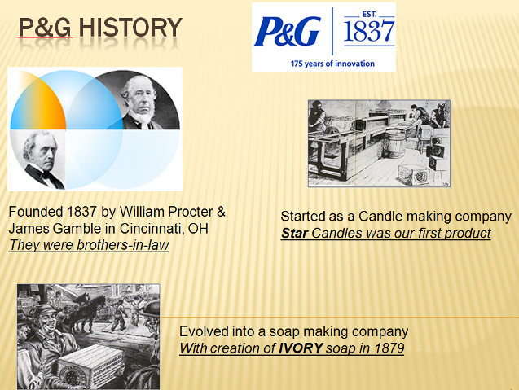

- Locations of P&G Merchandising Visits
Retailers serviced by P&G currently include Lowes Home Improvement Centers, Dollar General, and Family Dollar


- Timing of P&G Visits
Service/Project visits for P&G will vary based on the retailer and the project. You are representing different companies while you are visiting and servicing these retailers. Your positive attitude, preparedness and professional appearance will GUARANTEE a successful relationship with the store management.
Dress code is business casual. The following is acceptable business casual attire:
- Casual Dress Slacks (ex. khakis)
- Shirt with a collar (ex. polo shirt)
- Comfortable Shoes
- Driveline Name Badge

- Key P&G Brands by Category

LAUNDRY/FABRIC CARE
Tide uses an Acti-Lift formula to help lift off stains with ease. Tide has a range of products:
- Liquid Detergents in a variety of scents, Tide for High Efficiency Machines (HE), Ultra Tide Powder Detergents, Dye and Perfume free Liquid and Powder Detergents
- Tide Stain Release
- Tide To Go

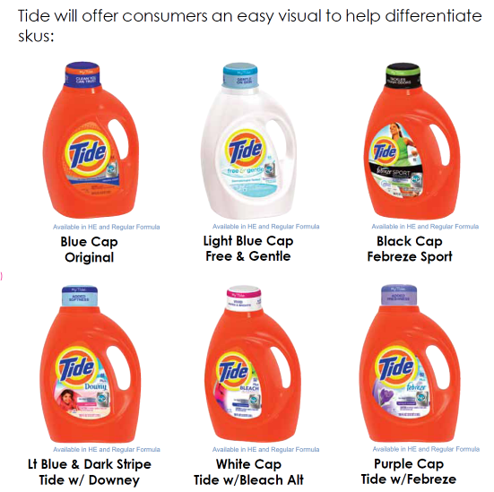

Gain has FreshLock technology that helps your clothes smell like they were pulled right from the dryer. Consumers can select the right gain product for their individual needs: Liquid, Powder, or HE detergents; fabric softeners, dryer sheets and dishwashing liquids!

Not only is Cheer on a mission to get your whites and colors sparkling bright, Cheer wants to keep them that way too! Cheer has improved the brightening in P&G’s Fresh Clean Liquid Formula. Cheer is available in liquid or powder.
2X Ultra Era’s concentrated formula gives Era’s stain-fighting power in a small convenient bottle.

Dreft is the #1 choice of pediatricians. Dreft is specially formulated to be gentle on a baby’s skin but tough on stains. Moms have trusted Dreft for over 75 years.

Pure Ivory Snow is a gentle care detergent for all fine washables. Ivory Snow is designed for whites, brights, darks, multicolor and all sensitive fabrics.

Downy infuses fabrics with wonderful softness, freshness and static control. Downy offers liquid and fabric softener sheets in a variety of scents.

Bounce helps to control static and repel lint and hair. Through innovation, Bounce created the Bound Bar that attaches safely to the inside dryers and freshens every load automatically.

Competitive Brands include:
- Laundry: All, Arm & Hammer, Purex, Xtra & Private Label
- Fabric Enhancer: Snuggle, Suavitel & Private Label

HOME CARE – DISH

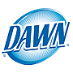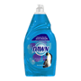
In each drop, Ultra Dawn has 30% more cleaning ingredients then the leading non-concentrated brand. Dawn comes in a variety of scents and types to ensure consumers find the right product for their needs.

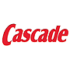
Cascade has many different varieties:
- All-in-1 Action Pac combines best of powder and gel
- Cascade All-in-1 Gel or Powder
- Cascade Complete with Bleach Hydroclean Action Gel or Poswer
- Cascade with Grease Fighting power of DAWN
- Cascade with Extra Bleach Action
- Cascade Rinse Aid
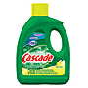

HOME CARE – SWIFFER
Swiffer Sweeper cleans 3X better than a Broom and cleans 50% more surface area then the leading store brands.

Swiffer Wet Jet cleans better than a mop & bucket or washable microfiber pads.
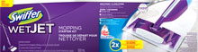
Swiffer SweeperVac cleans messes both big & small in one smart step. Swiffer SweeperVac has a powerful cordless vacuum for grabbing crumbs, leaves, pet hair and cereal; plus a textured Swiffer Dry Sweeping Cloth for trapping and locking fine dirt and dust.
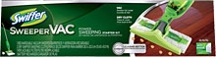

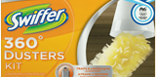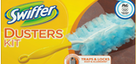
Swiffer 360 Dusters, Swiffer Dusters Extenders and Swiffer Dusters are built smarter to clean better. Fluffy fibers reach dust and allergens (from cats, dogs and dust mites) in nooks and corners, then trap and lock it away for good!
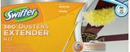

HOME CARE – AIR & SURFACE
Febreze Fabric Refresher eliminates odors from fabric and air for freshness that fills your home. You can use it on upholstery, curtains, carpets and the air.
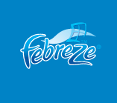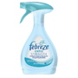

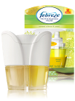
Febreze NOTICEables is innovative scented oil warmer you simply plug into any outlet for 30 days of uplifting fragrance.
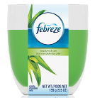
Febreze Candles can burn for up to 30 hours and the refreshing scent lingers long after you blow it out. Febreze Candles eliminates cooking smells and other everyday odors.
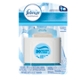
Febreze Set and Refresh air freshener eliminates odors while releasing a fresh scent that lasts noticeably longer because it slowly releases scented oils.
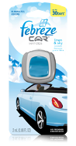
Febreze Car Vent Clips provide a fresh scent for up to 30 days in your car.
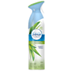
Febreze Air Effects sweeps away stifling odors from the air using P&G’s patented technology and leaves only a clean, refreshing scent.

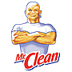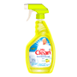
Mr. Clean Multi-Surfaces Liquid Cleaner & Spray Cleaner cuts grease, removes grime and leaves a light fresh scent. Use it to clean dirt and eliminate odors on linoleum as well as tile floors, toilets and bath-tubs.
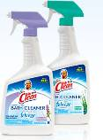
Mr. Clean Disinfecting Bath Cleaner with Febreze Freshness cleans 2X more soap scum per swipe while killing 99.9% of bacteria and helps eliminate odors with the freshness of Febreze.
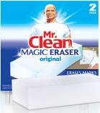
Mr. Clean Magic Eraser Original uses water activated micro-scubbers to reach into the surface grooves, lifting away built up grease and soap scum. You can use on your walls, baseboards, floors, switchplates, blinds and more to make things look like new again by easily removing scuff marks and dirt.

FAMILY CARE – PAPER

Bounty – Bounty offers varieties that match everyone’s needs for a paper towel. The strength and absorbency of original Bounty provides great value while allowing consumers to clean the mess with less*.

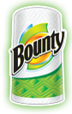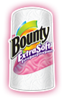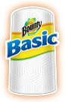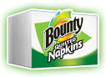
Bounty
Soaks up all the messes life brings.

Bounty Extra Soft Tough on messes. Soft on faces.

Bounty Basic Cleans up and holds up.

Bounty Quilted Napkins
Thick and absorbent so you can focus on the meal, not the mess.

Charmin - Charmin products are designed for consumers who prefer superior softness and absorbency in their toilet paper and strive for the most comfortable bathroom experience. Research has also shown that consumers use two times less Charmin product compared to the leading value brand—and it still leaves you noticeably clean.

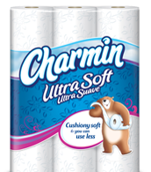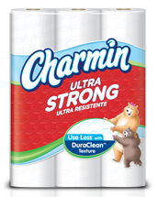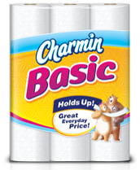

Charmin Ultra Soft
So cushiony soft and you can use 4X less*
Charmin Ultra Strong
Cleans so well you can use up to 4X less.*
Charmin Basic
2X stronger* with a great everyday price

Puffs Basic is still the same everyday-soft, non-lotion facial tissue you love, but with a prettier wardrobe! Try it for your everyday facial tissue needs. And unlike the leading regular tissues that are pressed flat, only Puffs facial tissues have Air-Fluffed™ pillows for 40% more cushiony thickness so you can put your best face forward.
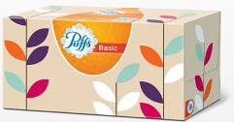

FAMILY CARE – DIAPERS

Pampers - Pampers is the world’s top-selling brand of baby diapers.

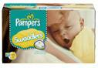
- Color-changing Wetness Indicator (size NB, 1 and 2)
- The #1 choice of hospitals (based on sales data)
- Quilted blanket-like softness wraps in comfort and security
- Soft, stretchy sides and overlapping fasteners for flexible fit
- Umbilical cord notch (size NB only)

- 3-Way Fit gives babies our best fit ever
- Up to 12 hours of leakage protection
- Now with the quilted softness of Swaddlers
- Your favorite Sesame Street characters on every diaper

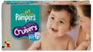

LUVS - Whether you have a newborn baby or an active toddler, Luvs® Ultra Leakguards help lock away wetness, day and night. These diapers can even help protect against blowouts! And don’t forget to clean up after big messes with pillowy Ultra Clean wipes.

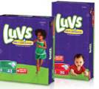
Pick a size, any size. If your little one is anywhere between just-home-from-the-hospital-tiny and wow-I-can-barely-pick-you-up-anymore, Luvs® Diapers will stop leaks.
The lotion in our wipes helps give your baby a thorough clean, and our alcohol-free formulation is great for sensitive baby skin.
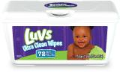

HEALTH & BEAUTY

Deodorant /Shave/Body Wash
Old Spice Deodorant/Body Wash
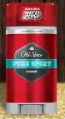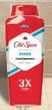

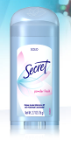
Secret Deodorant – Odor and Wetness protection
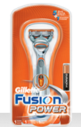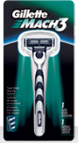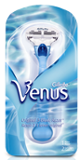
- Gilette Fusion & Gillette Mach 3 Razors ( Men’s razors)
- Venus (Women’s razors)

Shampoo/Conditioners

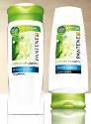

Pantene focuses on providing customized hair care products that empower women to look and feel their best every day.

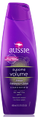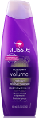
Aussie products offer no-worries hair care products for naturally beautiful hair

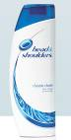

For over 50 years, Head & Shoulders has provided millions of consumers with superior scalp care.

Toothpaste/Mouthwash

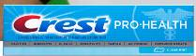

As a trusted leader in oral health, Crest helps consumers maintain healthy, beautiful smiles for life.

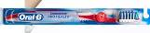

The Oral-B brand is a worldwide leader in the brushing market.

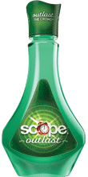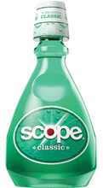
Get fresh with the delicious mint flavor of Scope Mouthwash.

Cough/Cold & Digestive

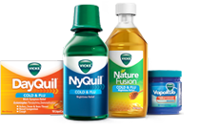
For cold, flu, and cough symptom relief and advice, Vicks has everything you need when you’re sick to make every day and night worth holding onto.

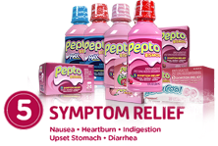
Pepto-Bismol relieves heartburn, indigestion, upset stomach, nausea, and diarrhea in one smooth dose.

Feminine Care
Always/Tampax - P&G is behind some of the biggest innovations in feminine hygiene history,
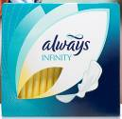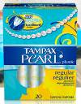

Cosmetics & Skin Care

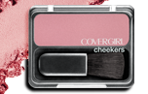

For fifty years, COVERGIRL has created must-have beauty products that bring out the best in women.

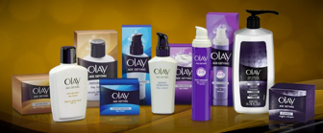

Olay is a worldwide leader in skin care and has been trusted by women for 60 years.

BATTERIES

Duracell - Trusted everywhere, Duracell has been meeting the power needs of people around the world for more than 40 years.

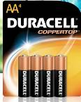
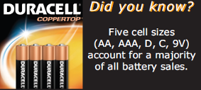

Duracell Copper-Top: Many of the battery-powered devices you use in your home are powered most efficiently by Copper Top Batteries.

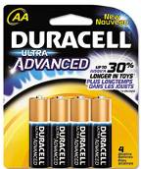
Duracell Ultra Advanced with Powercheck: These batteries are the best performing batteries in high drain devices such as toys.

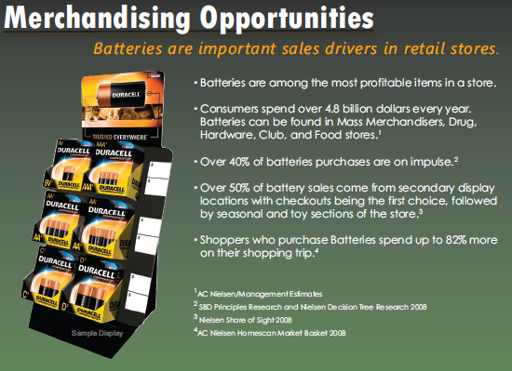

- Specific Retailer Displays/Fixtures

Lowes Home Improvement Centers

- Duracell Battery Display Types
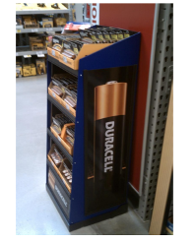
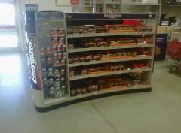
Battery Center
Duracell Rolling Display

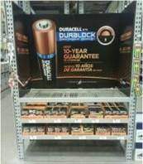
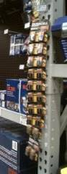
Duracell Duralock Endcap
Duracell ClipStrip
Duracell Rolling Rack

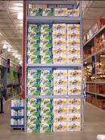
- Bounty/Charmin Display Types

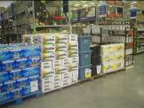
Pallet Display
End Cap Display

- Tide/Gain/Swiffer Display Types

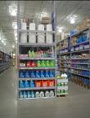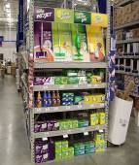
Tide/Gain End Cap Display
Swiffer Display

Family Dollar Stores

Health & Beauty Sections (varies by store)

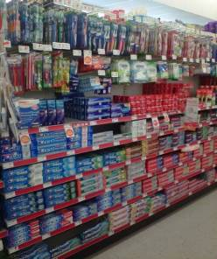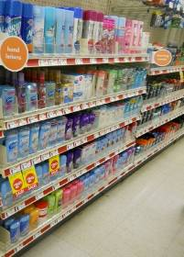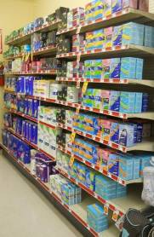
Oral Care: Crest, Scope and Oral-B
Deodorant/Shave: Gilette/Secret/Old Spice

Feminine Hygiene: Always/Tampax


Over-the-Counter Medicine: Pepto Bismol

Home Care Sections (varies by store)
P&G Brands in these sections would be:

